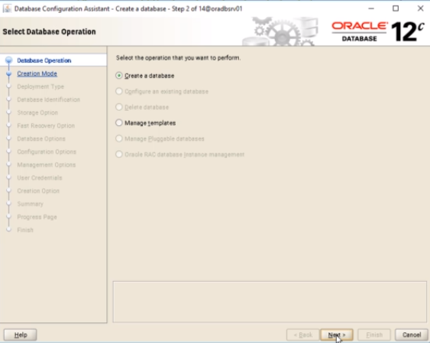

Create database next

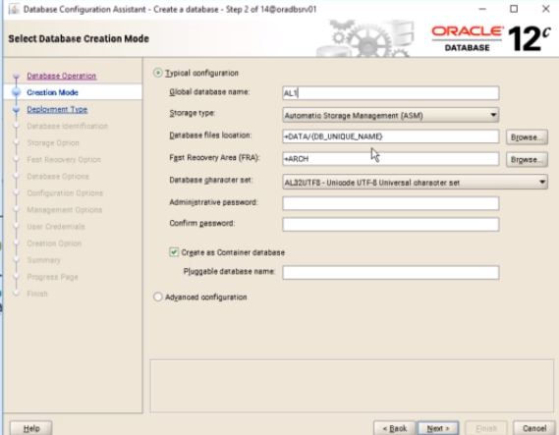

AL1

Nome do banco

Asm (automatic storage managent)

Usando o asm, ja que criamos o grid para gerenciar

Senha: Pedro389102 desmarcar

create as container database DESMASCAR

next

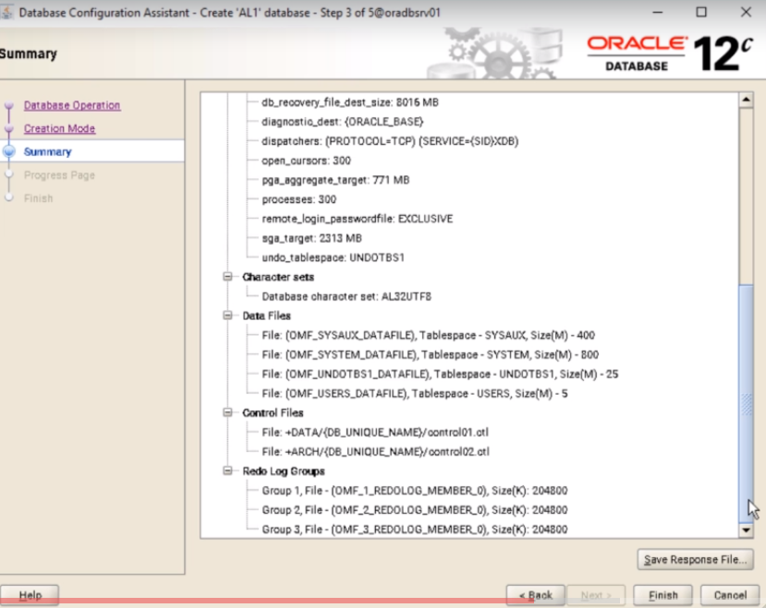

Finish

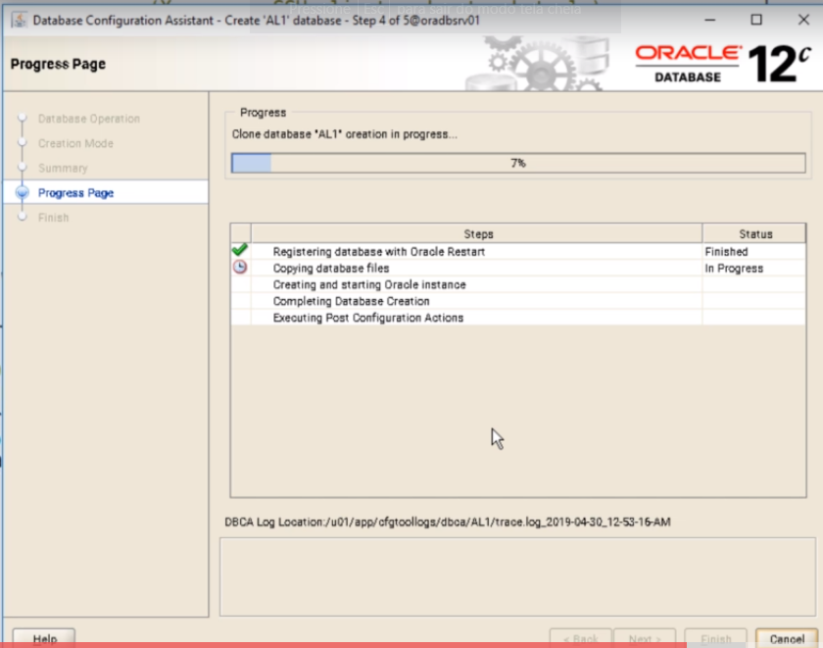

Aguardar

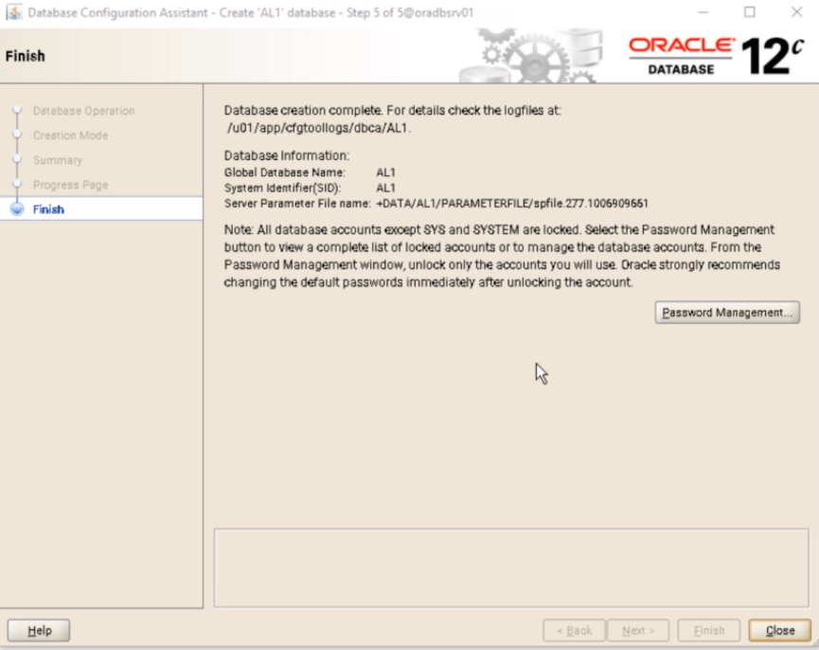

Finish

Usuário oracle

Testar a conexão

Export ORACLE_SID=AL1

Sqlplus / as sysdba

Select status from v$instance;

Ou

srvctl status database -d AL1